1. Introduction

1.1 Purpose/Problem Definition :

The project is about an automobile company website known as ‘BMW’. The main focus of our project is to inform the users about the specifications of our different vehicles. The user can also register for a test drive of the vehicles listed on the website. The user can also compare various cars and bikes listed on the website.

1.2 Scope :

This type of website can be used for various other products where the customer can research about the product before buying it. The customer can compare the various products provided by the company. The customer can give a test run to the product can by it according to what is suitable for him. This way the customer gets a good service where he is satisfied as he becomes completely aware of what he is buying and the performance of the product.

1.3 References

[www.w3schools.com](http://www.w3schools.com)

[www.bmw.com](http://www.bmw.com)

[www.tutorialspont.com](http://www.tutorialspont.com)

2. Overall Description

2.1 User Interfaces/interfaces.

The following interfaces are required.

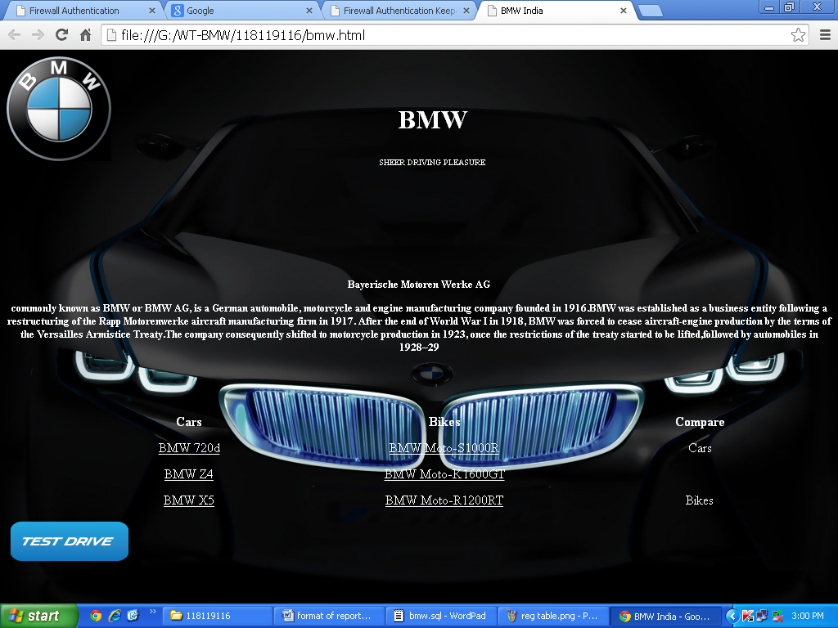

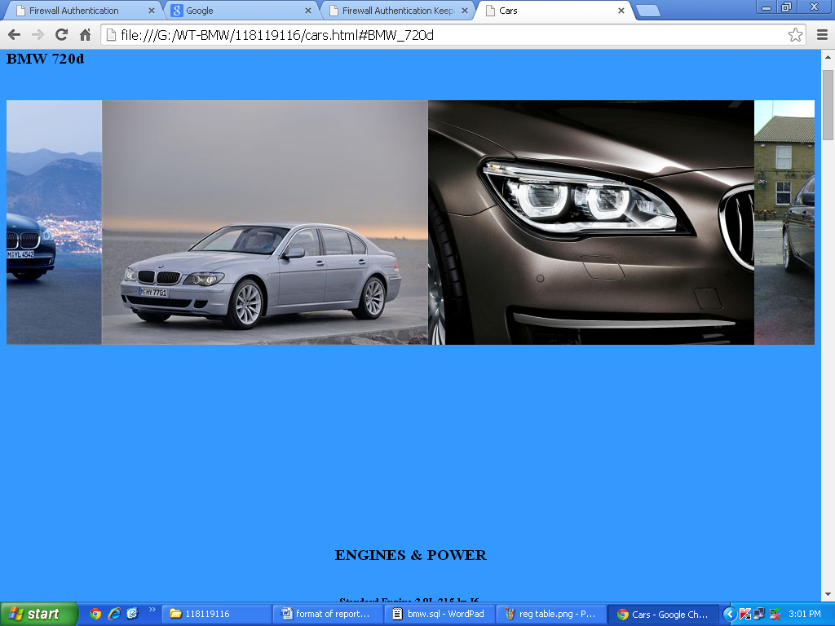

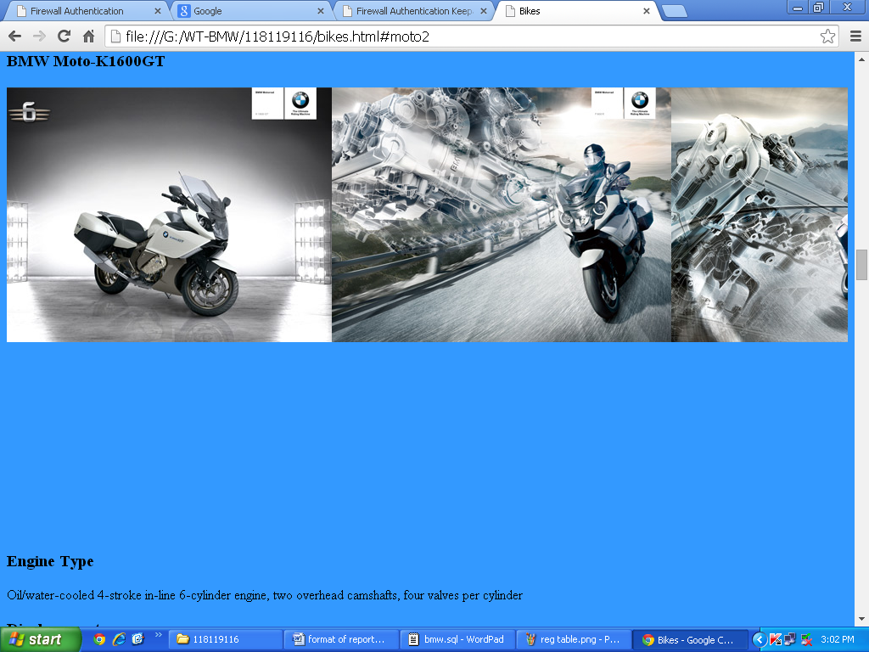

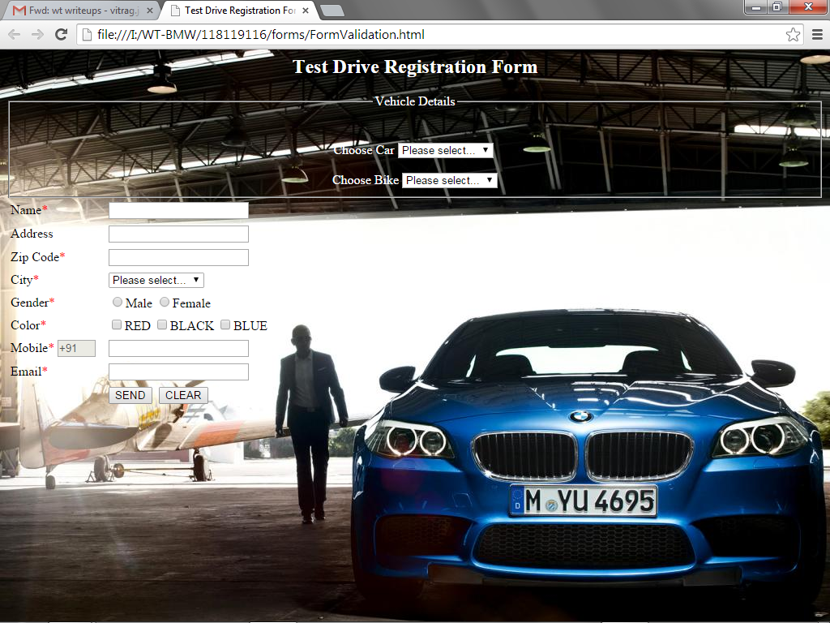

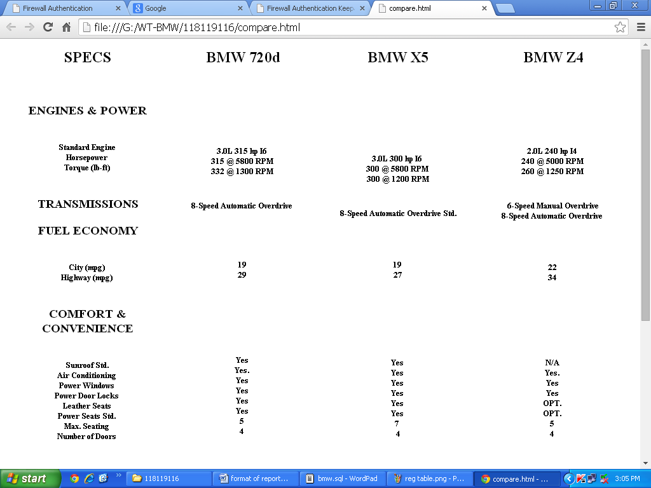

2.2. Hardware Interfaces (H/W Requirements)

* Computer(Minimum specs : 800 MHZ,256 MB RAM)
* Computer will need to be connected to an internet connection with a fixed IP address.
* Monitor Resolution – 1024x768

2.3. Software Interfaces(S/W Requirements)

* HTML 4
* WAMP Server
* CSS 3

2.4. Website requirement

* Browsers – preferably Google Chrome or Mozilla Firefox.
* Screen Resolution – 1024x768
* Internet Connection with fixed IP address

3. Software product features

3.1 Navigation

* Hyperlinks
* Named Anchors
* Dropdown Menu

3.2 Aesthetic layout

* The home page of the website has a background of picture of a car.
* There is a brief description of the company.
* The logo of the company is on the top left corner.
* It has anchors to the various cars and bikes where the information is provided about them.
* A test drive button is provided which directs the user to the registration form.
* There is a link provided to compare the various cars and bikes.
* On the car information page a marquee effect of the pictures of the cars and bikes scrolling from right to left.
* On the comparison page, frames is used to show to show the comparison of the cars and bikes.

3.3 Effective graphic design

* Background image of a car.
* Transition on the test drive button
* Marquee effect from right to left displaying multiple images of cars and bikes.

3.4 Self Explanation

* The website provides the information of the various cars and bikes.
* It allows the user to compare their specifications.
* It allows the user to register and request for a test drive.

3.5 Logical database requirements

List the database details.

Database name : BMW

Tables used (with structure)

Code :

-- phpMyAdmin SQL Dump

-- version 3.2.0.1

-- http://www.phpmyadmin.net

--

-- Host: localhost

-- Generation Time: Oct 13, 2014 at 03:52 AM

-- Server version: 5.1.36

-- PHP Version: 5.3.0

SET SQL_MODE="NO_AUTO_VALUE_ON_ZERO";

/*!40101 SET @OLD_CHARACTER_SET_CLIENT=@@CHARACTER_SET_CLIENT */;

/*!40101 SET @OLD_CHARACTER_SET_RESULTS=@@CHARACTER_SET_RESULTS */;

/*!40101 SET @OLD_COLLATION_CONNECTION=@@COLLATION_CONNECTION */;

/*!40101 SET NAMES utf8 */;

--

-- Database: `bmw`

--

-- --------------------------------------------------------

--

-- Table structure for table `registration`

--

CREATE TABLE IF NOT EXISTS `registration` (

`id` int(11) NOT NULL AUTO_INCREMENT,

`car` text NOT NULL,

`bike` text NOT NULL,

`name` text NOT NULL,

`gender` text NOT NULL,

`email` text NOT NULL,

`address` text NOT NULL,

`zipcode` bigint(6) NOT NULL,

`mobile` bigint(20) NOT NULL,

PRIMARY KEY (`id`)

) ENGINE=MyISAM DEFAULT CHARSET=latin1 AUTO_INCREMENT=1 ;

--

-- Dumping data for table `registration`

--

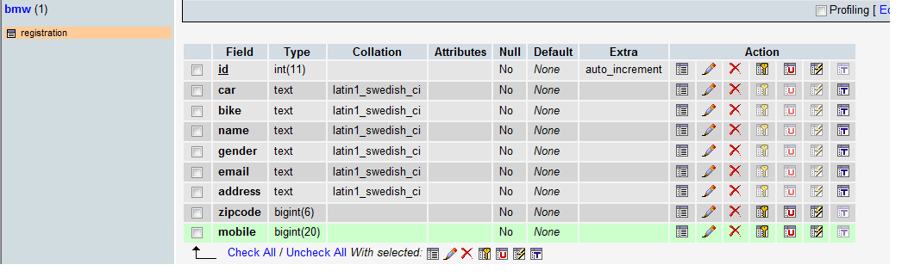

**Date: _____________ Signature of faculty in-charge**